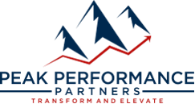
For Immediate Release
August 25, 2025
Peak Performance Partners Launches Business Excellence Training Classes
Monthly in-person trainings equip company leaders with the tools to improve communication, boost sales, streamline operations and craft strategic plans
Las Vegas, NV – Peak Performance Partners, Nevada’s premier business consultancy, is launching new Business Excellence Training Classes designed to equip business owners, executives and company leaders with practical tools to drive performance, improve communication and accelerate growth. Starting in September, the monthly workshops will take place at the company’s headquarters located at 3127 E. Warm Springs Rd., Suite 400, Las Vegas, NV 89120. These sessions will provide hands-on, results-driven training on critical leadership topics ranging from mastering communication and sales strategies to building strategic plans and reclaiming time.

“Too many business leaders are stuck in the hamster wheel of working in their business instead of on it,” said Ricky Navar, president of Peak Performance Partners. “These workshops are designed to change that by giving owners and executives the tools to take back control of their time and build a stronger company by developing stronger leaders.”

Each two-hour session is priced at $499 and is designed to help company leaders strengthen their teams, boost revenue and create lasting organizational impact:

- Decode the People Puzzle: Mastering Communication for Leadership Impact – September 30 from 10 a.m.-12 p.m.
This workshop helps teams identify and adapt to different communication styles to improve collaboration, reduce conflict and strengthen team dynamics. Using insights from DISC, participants learn how to connect more effectively with colleagues and direct reports to drive impact and become the kind of organization that people want to work for.

- The Science of the Sale: Strategies That Close Deals – October 28 from 10 a.m.-12 p.m.
This session will empower teams to build trust faster, uncover real customer needs and move prospects from interest to commitment with confidence. Perfect for leaders looking to boost revenue and sharpen their competitive edge.

- From Vision to Victory: Building Strategic Plans That Work – November 19 from 10 a.m.-12 p.m.
This hands-on workshop guides participants through creating a focused, actionable strategic plan to align their team and drive measurable growth. Leave with a roadmap to success – clear, customized and ready to execute.

- Buy Back Your Time: Mastering Time & Calendar for High-Impact Leaders – January 14 from 10 a.m.-12 p.m.
Your most valuable asset isn’t money—it’s time. Learn how to take back control of your calendar, eliminate time-wasting habits, and prioritize what really moves the needle. This session helps leaders shift from reactive to strategic, making space for what truly matters.
These classes underscore Peak Performance Partners’ commitment to offering top-tier expertise in business transformation and operational improvement. Based in Las Vegas, Peak Performance Partners provides a range of services, including business consulting, strategic planning, sales process optimization, and professional business coaching. The company specializes in financial performance analysis, human capital management, personal development, process optimization across all departments, and exit planning and succession strategies.

For additional information and to register, visit: https://3-peak.as.me/schedule/ad67d75d.

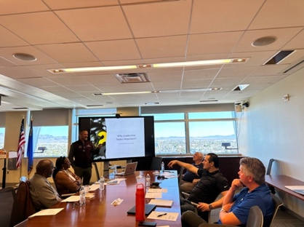
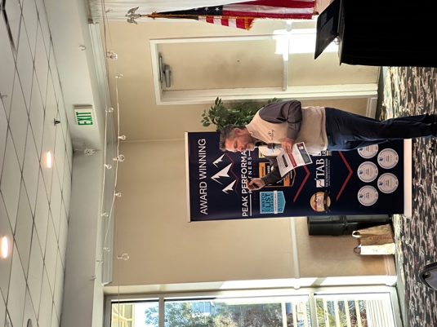
About Peak Performance Partners
Peak Performance Partners is Nevada’s premier business consultancy, dedicated to empowering CEOs and business owners with the tools, strategies and mindset essential for success. The company’s proven methods and systemized processes transform businesses into industry leaders, guiding clients through each strategic move to reach and exceed their goals.

Based in Las Vegas, Peak Performance Partners provides a range of services, including business consulting, strategic planning, sales process optimization, and professional business coaching. The company specializes in financial performance analysis, human capital management, personal development, process optimization across all departments, and exit planning and succession strategies. Through a vast network of business owners and executives, Peak Performance Partners supports clients in defining and achieving their business objectives with confidence and precision.

For more information, visit www.3-peak.com or follow Peak Performance Partners on Instagram, Facebook and LinkedIn. Peak Performance Partners is open Monday through Friday from 8am to 5pm and appointments can be made by calling (833) 726-9675.

###
Media Contact:
Mallory Zito
GYC Vegas
(702) 964-4222
mallory@gycvegas.com

